PROBLEM SOLVING PROCESS-DMAIC

Define
Phase

Title: MMS Open Work Orders

Start Date June 11, 2003
Written by: Tenley Wiltshire
Process Owner: Bruce Campbell

Problem: Current Situation

An increasing number of Work Orders are left open in the MMS delaying the invoicing of these work orders. Customer satisfaction is greatly affected as the number of jobs are not being completed. Because of the incomplete Work Orders opened for the past six months, revenue for Bombardier is not captured

Desired Situation:
Reduce the number of Designated/Unscheduled Repairs open workers on a monthly basis.

Define the problem

Why – Why is it a problem?

Where – Where is the problem occurring?

Who – Who is affected?

What – What is the nature of the problem?, Part no., serial no., …

When – When does it happen? At what frequency?

How – How do we know it's a problem? (Evidence)

How Many – Quantify the problem
Measure
Phase
Quantify the problem
Based on the calculated data on the graph below, the average amount of Designated/Unscheduled Repairs work orders left opened for the period of January 2003 to June 2003 was = 28 work orders

Methods |  | Machines |  | Materials |  | Manpower |  | Environment
 | Ass. Drawing |  | Equipment |  | Parts | x | Training |  | Work area
 | Instructions |  | Tools |  | Specifications |  | Qualification |  | Lighting
 | Line Balancing |  | Gages |  | Drawings | x | Experience |  | Temperature

Probable Causes

Quantify the problem
Prove with data that there is a problem.

Probable Causes
Identify the elements that may be at the problem’s origin and collect all existing pertinent documentation.
Critical characteristics measurements

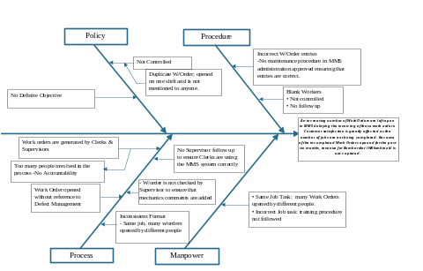
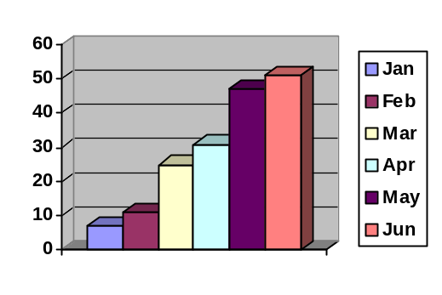Measure of selected characteristics
From the probable causes and the documentation, determine the critical characteristics to be checked (dimensions, speci-fications, instructions, …). Illustrate if possible.

Measure the critical characteristics and record your measurements in a table, graphical or diagram format.

Analyze
Phase
Conclusions of the Analyze phase

From the information provided in each Category on the Chart calculated on a monthly basis, average revenue lost by Bombardier is $2,583.02

From the information given in the Pareto Chart “No Supervisor follow up” has the Highest defects recorded

Conclusions of the Analyze phase results
What are the conclusions? Are the existing specifications met?

Analysis of the causes

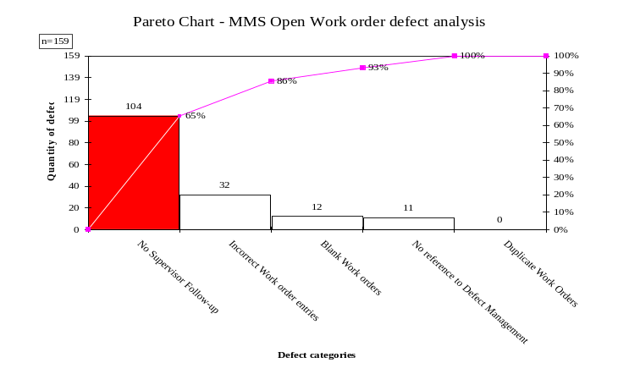
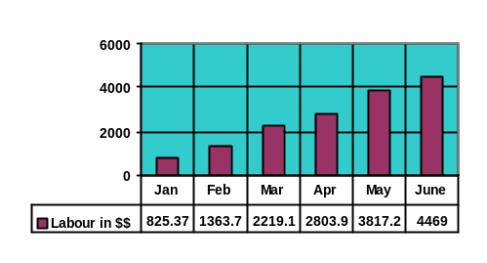Analysis of the causes
Identify failures and / or causes for non-conformity. Illustrate with diagrams

Select the causes for which an improvement must be made to correct the problem.

Improvements implemented:

1. A Clear defined procedure should be implemented outlining each step taken in
the process from when a w/order is requested to when a work order is completed

Please refer to Figure 1A

2. Each Clerk/Supervisor should address all open w/orders before the invoice cutoff date.

3. Training should be provided for Supervisors/Managers & Clerks on newly defined process.

4. The QA/QC Department should perform routine weekly audits on open work order following the guidelines listed

NB: To proper evaluate results, daily audits for a period of seven days would be done initially commencing August 11th to August 18th .

Open work orders should be checked for:
- Parts and labour are listed to that specific w/order
- Correct Job name ( Designated or Unschedule Repairs )
- Serialized components and information on wheel sizes if required
- Assigned Unit number should be the same as the parts allocated to it
- Duplicate work orders from both Defect Management and Work Order Log in MMS

Please refer to Figure 1B

Results obtained vs. goals: Please Refer Pareto Chart Below

MMS Open Work order Defect categories Qty. of defects
Duplicate Work Orders 0
Work order with no reference to Defect Management 1
No Supervisor Follow-up 7
Incorrect Work order entries 0
Blank Work orders 0
Long Processing Time 8
Out of Service (206) 7
Waiting for Parts 3

Validate Results Vs Goals :

Results obtained vs. goals:

Improve
Phase

Type of improvement implemented

Bring part to Specification
Specification Correction
Create specifications

Improvements implemented and results

Specify:
- Type of improvements
- Details of Improvements
(Illustrate with a sketch if possible)
- Name: Resp. for application
- Date
- Status (% complete)

Describe the effects of the improvements on the problem.

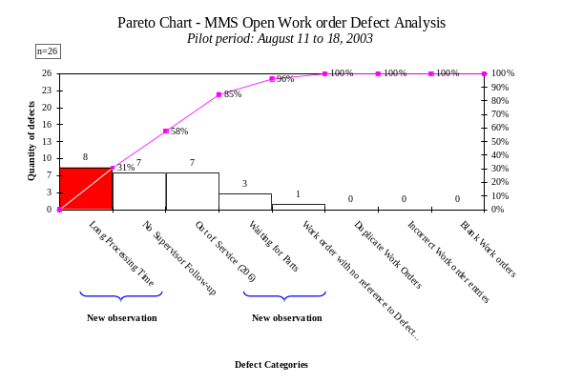

Control
Phase

Validation of implemented improvements. Is the problem fixed for good? If not, why not?

With reference to the data recorded before and after the pilot was completed, the improvements implemented were successful.

Corrective Action No
(if applicable)

Validation of implemented improvements

Implementation of Control Means. How to prevent the problem from reoccurring?

Refer to QA Procedure SHOP PW-011, Flow Chart (Figure 1A) and Control Plan

Fermeture du problème

Nom Date Nom Date

Fermeture du problème

Nom Date Nom Date
Validate that the improvements keep their effect with time.
If improvements are temporary only or do not address the root causes, make sure you identify corrective actions.
Project Closure

Analyst Date Process Owner Date
Implement Control Means
Document which control means are to be put in place to maintain the improvement or to prevent the problem from reoccurring.
Project Closure

